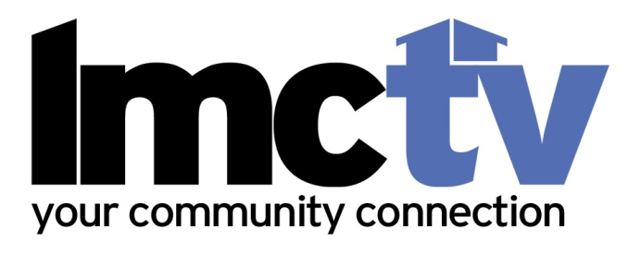

Parental Consent Form

Larchmont Mamaroneck Community Television, Inc (LMC-TV) is a non-profit organization that programs cable channels 75, 76, 77 on Cablevision and 34, 35, 36 on Verizon/Fios in the Larchmont, Mamaroneck and Rye Neck communities. LMC-TV aims to heighten community awareness and increase community participation though the making and viewing of local television and to encourage programming that reflects the concerns, interests, and activities of our community. We maintain three production facilities for community use, open to residents on a first-come, first-serve basis.
LMC-TV depends on volunteers. Please indicate below, on the appropriate line, that you give permission to your son/daughter who is under the age of 18 to volunteer on programs produced using LMC-TV equipment and facilities.
Name of minor volunteer (please print clearly)
Age:
Name of Parent or Guardian (please print clearly)

Signature of Parent or Guardian
Date:

